Cairo University  
Faculty of Computers and Information



**CS251**

**Software Engineering I**

PlayWell

Software Design

HAO

December 2016

Contents

Instructions [To be removed] 3

Team 3

Document Purpose and Audience 3

System Models 3

I. Class diagrams 3

Important Algorithm 5

II. Sequence diagrams 5

Class - Sequence Usage Table 7

Ownership Report 8

Policy Regarding Plagiarism: 8

References 8

Authors 8

# Team

|  |  |  |  |
| --- | --- | --- | --- |
| **ID** | **Name** | **Email** | **Mobile** |
| **20140099** | **Hossam Khalid El-hawary** | [**Hossam.elhawary1996@gmail.com**](mailto:Hossam.elhawary1996@gmail.com) | **01270919719** |
| 20140185 | Omar Adel Mohamed Ramzy | [Omar.ramzyi@gmail.com](mailto:Omar.ramzyi@gmail.com) | 01010539322 |
| 20140163 | Abdurrahman Mahmoud | [Abod.mahmoud92@gmail.com](mailto:Abod.mahmoud92@gmail.com) | 01000495565 |
| 20140171 | Abdullah abdullmoneim Gerbil | abdullahgebreil@gmail.com | 01117940752 |

# Document Purpose and Audience

* **This document is written to illustrate class diagram and sequence diagram.**
* **This document should be read by (project manager and developers)**

# System Models

## I. Class diagrams

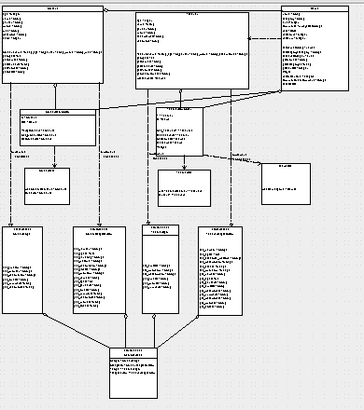

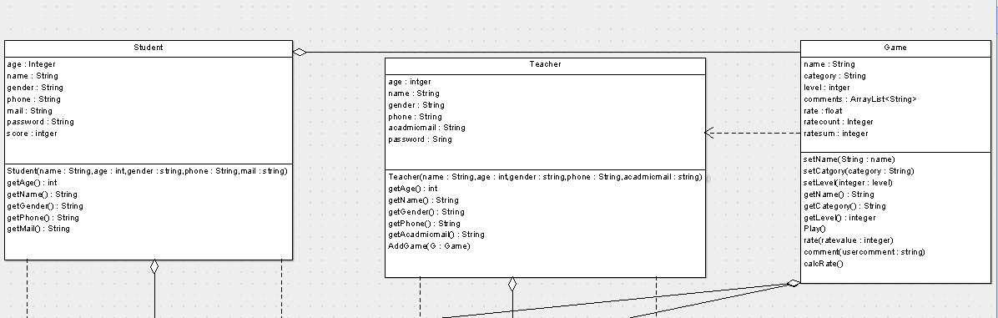

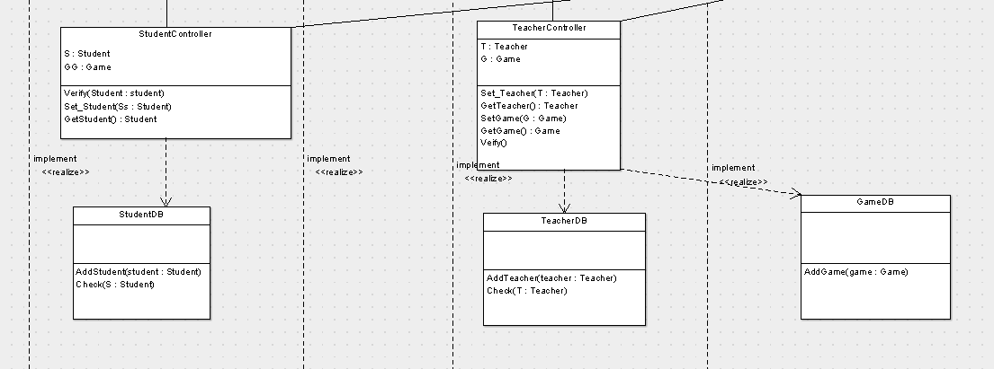

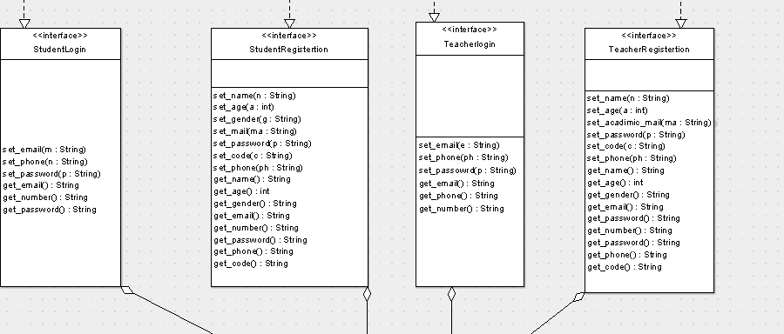



| **Class ID** | **Class Name** | **Description & Responsibility** |
| --- | --- | --- |
| 1 | Student | Describe student actions.  responsible for student information |
| 2 | Teacher | Describe teacher actions.  responsible for teacher information |
| 3 | Game | Represent game and how to play it and how the user will deal with it. |
| 4 | StudentController | Control student functions in the system and how the student will be verified in the system |
| 5 | TeacherController | Control teacher functions in the system and how the teacher will be verified in the system |
| 6 | StudentDB | Represent student database and how data managed in it |
| 7 | TeacherDB | Represent teacher database and how data managed in it |
| 8 | GameDB | Represent game database and how data managed in it |
| 9 | StudentLogin | Interface for student log in responsible for getting data from user to log in |
| 10 | TeacherLogin | Interface for teacher log in responsible for getting data from user to log in |
| 11 | StudentRegistretion | Interface for student to sign up responsible for collecting data from student to register |
| 12 | TeacherRegisteration | Interface for teacher to sign up responsible for collecting data from teacher to register |
| 13 | maininterface | Control system interface |

### Important Algorithm

## II. Sequence diagrams

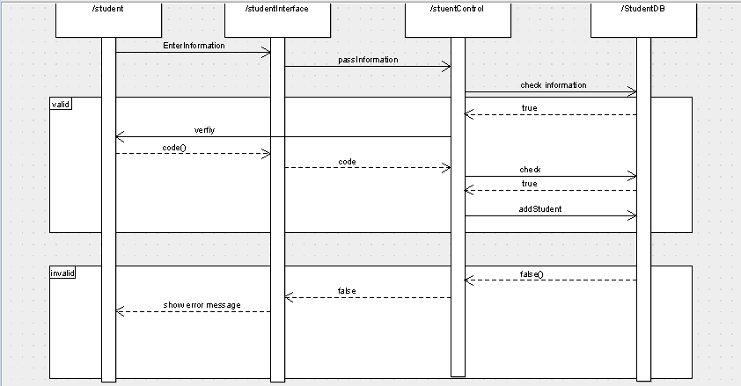

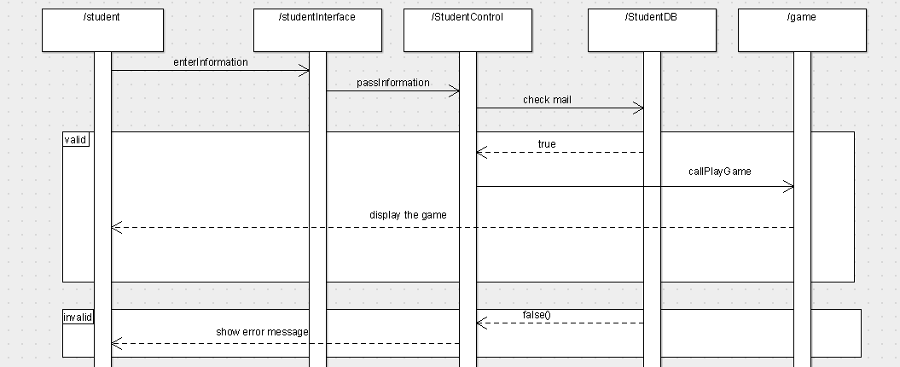

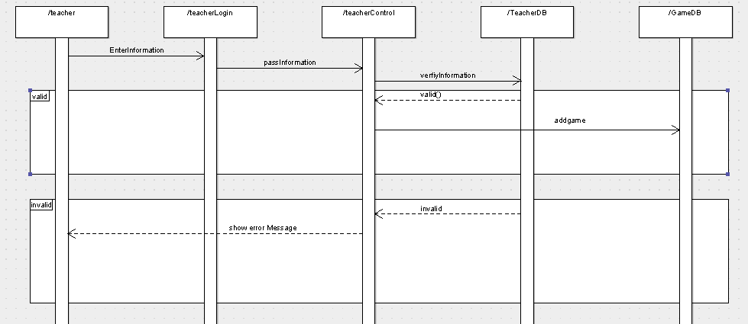

### Class - Sequence Usage Table

| **Class Name** | **Sequence Diagrams** | **Overall used methods** |
| --- | --- | --- |
| E.g. Employee | 1, 3, 5 (means Seq Ids 1, 3, 5 used Employee class) | Save, GetData |
|  |  |  |

# Ownership Report

|  |  |
| --- | --- |
| **Item** | **Owners** |
| Class diagram | *Omar , abdel rahman , hossam* |
| Sequence diagram | *Abdel Rahman ,abdullah* |
| Templet | *hossam* |

# Policy Regarding Plagiarism:

1. تشجع الكلية على مناقشة الأفكار و تبادل المعلومات و مناقشات الطلاب حيث يعتبر هذا جوهريا لعملية تعليمية سليمة
2. ساعد زملاءك على قدر ما تستطيع و حل لهم مشاكلهم فى الكود و لكن تبادل الحلول غير مقبول و يعتبر غشا.
3. أى حل يتشابه مع أى حل آخر بدرجة تقطع بأنهما منقولان من نفس المصدر سيعتبر أن صاحبيهما قد قاما بالغش.
4. قد توجد على النت برامج مشابهة لما نكتبه هنا أى نسخ من على النت يعتبر غشا يحاسب عليه صاحبه.
5. إذا لم تكن متأكدا أن فعلا ما يعد غشا فلتسأل المعيد أو أستاذ المادة.
6. فى حالة ثبوت الغش سيأخذ الطالب سالب درجة المسألة ، و فى حالة تكرار الغش سيرسب الطالب فى المقرر.

# References

* http://www.mhhe.com/engcs/compsci/pressman/graphics/Pressman5sepa/common/cs1/design.pdf

# Authors

* Mostafa Saad and Mohammad El-Ramly (Edited by Mohamed Samir)